Development of the 'Spot' mobile application to improve the cleanliness of commercial spaces in the city of Mérida, Yucatán
Alejandro Maldonado, Eduardo Camacho, Emiliano contreras, Saul Ek, , Juan Che, Universidad Autónoma de Yucatán

Abstract
This article documents the user-centered design and engineering process of the mobile application "Spot," a crowdsourcing and collaborative economy platform aimed at addressing solid waste accumulation and toxic leachate ("black paste") in the bustling commercial zones of Mérida, Yucatán. Leveraging the principles of Human-Computer Interaction (HCI) and User-Centered Design (UCD), the project bridges the service delivery gap left by public utilities. This study walks through the foundational phases: project definition, user profiling (personas and scenarios), comparative market analysis, requirements engineering (IEEE 830), and interaction modeling using the Keystroke-Level Model (KLM). A predictive KLM evaluation of the critical "merchant reporting" scenario yielded an execution time of 26.55 seconds, verifying high usability. Finally, a rigorous field-usability test framework with five participants is proposed to empirically validate the application's responsive interface and localized socio-ecological impact.
Summary
This article documents the process of user-centered design and software engineering of the mobile application "Spot", a collaborative economy platform aimed at mitigating the accumulation of highly harmful urban solid waste and leachate ("black paste") in the commercial areas of Mérida, Yucatán. Based on the principles of Human-Computer Interaction (HCI) and User-Centered Design (UCD), the project solves the operational "accountability gap" of traditional public services. The article details the fundamental phases: definition of the problem, user modeling using people and scenarios, comparative market analysis, formal specification of requirements (IEEE 830) and predictive performance modeling using the Keystroke Level Model (KLM). The trader's predictive critical scenario assessment estimated an execution time of $26.55 seconds, validating a low cognitive load. Finally, the experimental framework for field usability tests with five participants is proposed to empirically validate the effectiveness of the interface and its local socio-ecological impact.
Keywords— Collaborative Economy, Human-Computer Interaction, Waste Management, User-Centered Design, Geofencing, Mérida.
I. Introduction
In the state of Yucatán, commercial activity is one of the primary economic engines, concentrating a substantial part of the labor force and the daily flow of citizens in markets, bazaars and retail stores in the Historic Center of Mérida. On a daily basis, this massive influx generates tons of Urban Solid Waste (MSW) that exceed the capacity of adjacent municipal containers. Faced with this insufficiency, tenants usually deposit bags of waste directly on the pedestrian sidewalks at the end of the day.
The prolonged accumulation of this waste gives rise to a critical phenomenon of environmental and health degradation. The accelerated decomposition of organic matter, catalyzed by high local temperatures and rainfall, generates a dark, dense and toxic liquid waste technically known as leachate and popularly known as "black paste". This fluid not only gives off foul odors and attracts harmful fauna (vectors of infection such as flies and rodents that threaten the food safety of businesses), but also impregnates the pedestrian concrete, severely deteriorating the tourist image of the city. It also exposes business owners to regulatory fines and closures by health authorities such as COFEPRIS.
The current waste collection system, managed by public administrations under rigid routes and schedules, lacks the necessary flexibility to solve immediate sanitation emergencies. This generates what we call a "responsibility vacuum": a space of inaction where neither the city council nor the passer-by assume the task of immediately cleaning the public road.
The "Spot" mobile application was created to dissolve this responsibility vacuum through a digital collaborative economy model. Its purpose is to articulate efforts of three key actors (citizens, merchants and autonomous cleaning brigades) to clean up commercial areas in an agile and autonomous way.
A. Project Objective
Design, prototype and evaluate a mobile application based on collaborative economy that reduces the time accumulated and leachated waste remains in commercial areas of Mérida, Yucatán. The platform should simplify the collection of citizen reports georeferenced with photographic evidence and create a dynamic market of instant cleaning offers, supported by physical validation methods through geofencing.
B. Rationale and Benefits
The development of "Spot" is based on three aspects of impact:
- Social and Health: It dignifies the conditions of transit and work in the city's public markets by reducing vectors of infection and eliminating visual and olfactory pollution of "black paste".
- Economic: It provides an extra and flexible source of income for autonomous urban brigade members. The financing is sustainable, since it comes from direct private micro-payments made by commercial tenants (estimated between $200 and $500 MXN) interested in protecting their clientele and image against possible health inspections.
- Environmental (Water Justice): The karst soil of the Yucatan Peninsula is extremely permeable, which makes it easier for leachate accumulated in the pavement to leak directly into the underground aquifer (the only source of drinking water in the region). By incentivizing immediate sanitation and enforcing the use of biodegradable chemicals (RNF-05) by digital contract, "Spot" acts as an ecological preservation shield.
II. Theoretical Framework and Similar Systems
The functional architecture of "Spot" is based on two technological pillars supported by the literature of Human-Computer Interaction:
- Geofencing Technology: Delimitation of virtual geographical boundaries that allow the system to verify in real time if the brigade member physically attended the perimeter of the report to execute the service, reducing fraud and consolidating a control of trust without direct human supervision.
- Gamification (Motivation Mechanics): Integration of leaderboards, ecological reputation badges and cumulative points systems to meet the social recognition needs of collaborating citizens and build loyalty in their active use of the application.
To study the viability and originality of the system, the market for existing platforms in Mexico and Latin America was analyzed in a comparative way (Table I, Annex at the end of the article).
II. Materials and Methodology
To ensure that the software responds to the real needs of its social context, the User-Centered Design (UCD) methodology was adopted iteratively:
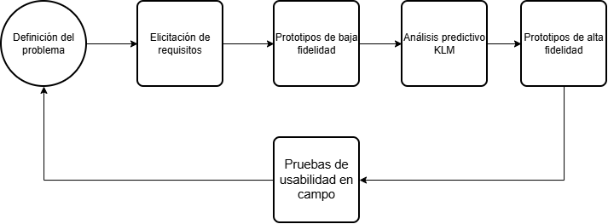
A. Elicitation of Requirements
A mixed methodological approach was applied that combined:
- Direct Observation Ethnography: Guided tours at critical times of garbage generation (7:00 AM and 6:00 PM) in the surroundings of the Lucas de Gálvez and San Benito municipal markets.
IV. Design Analysis (KLM Model)
To quantitatively validate the navigation efficiency of the interface before writing the source code, the predictive technique KLM (Keystroke-Level Model) was applied. The flow of the scenario of Roberto Méndez (Tenant) was selected, as he is the user with the highest probability of leaving the flow due to the visual saturation and multitasking of his workday.
A. Adjustment of KLM Operators to the Profile
The standard physical constants of the KLM model were rigorously calibrated according to Roberto's psychophysical profile (48 years old, mild presbyopia, mid-range mobile touchscreen and a noisy market environment):
- Virtual keystroke (K): 0.35s (due to the use of large characters on a touch keyboard).
- Confirmation touch or button (B): 0.15s (physical response time on mid-range displays).
- Point/locate an on-screen item (P): 1.50s (adjusted for lower near visual acuity).
- Mental Preparation / Cognitive Load (M): 1.50s (Bob must constantly alternate his attention with the customers in his store).
- Move your hand to the device (H): 0.40s (take your cell phone from your pocket or counter).
- System Network Response Time (R): 2.00s (Mobile Standard Latency under local 4G networks).
B. Logical Sequence of Steps (Scenario 1)
Roberto detects leachate dripping from a truck in front of his store at 7:00 AM and proceeds to make a report with a quick payment offer through the "Spot" application:
- Step 1: Bob takes his mobile phone from his counter. (Assignment: H)
- Step 2: Mentalize the opening of the app. (Assignment: M)
- Step 3: Look for the "Spot" icon on your home screen. (Assignment: P)
- Step 4: Tap on the "Spot" icon. (Assignment: B)
- Step 5: Wait for the app to load the map interface. (Assignment: R)
- Step 6: Examine the map and locate the floating dynamic "New Report" button. (Assignment: P)
- Step 7: Tap the "New Report" floating button. (Assignment: B)
- Step 8: Focus the system's built-in camera at the curbside debris stain. (Assignment: P)
- Step 9: Press the touch shutter button to capture the photographic evidence. (Assignment: B)
- Step 10: The system processes the image and automatically extracts the GPS coordinates. (Assignment: R)
- Step 11: Bob decides whether to add descriptive information. (Assignment: M)
- Step 12: Decide to write a brief explanatory text for the brigade. (Assignment: M)
- Step 13: Type the comment: "Black pasta in front of my shop" (approximately 30 characters). (Assignment: 30\times K)
- Step 14: Decide to submit the report and visually look for the "Send Report" button. (Assignment: M)
- Step 15: Tap on the "Send Report" button. (Assignment: B)
- Step 16: The system uploads the receipt confirmation and publishes it to the global map. (Assignment: R)
- Step 17: Bob takes in the visual message "Report Successfully Published!". (Assignment: M)
- Step 18: Tap "Back to Start" to continue serving your business. (Assignment: B)
C. Mathematical Expression and Calculation of the Estimated Time
By bringing together all the mapped operators, we get the following integrated algebraic expression:
Total Time = 2H + 5M + 3P + 5B + 3R + 30K
Total Time = (20.40s) + 5(1.50s) + 3(1.50s) + 5(0.15s) + 3(2.00s) + 30(0.35s)
Total Time} = 0.80s + 7.50s + 4.50s + 0.75s + 6.00s + 10.50s
Total Time = 30.05 seconds
The mathematical model estimates that the trader can successfully complete the critical task in 30.05 seconds. According to IHC literature standards, any mobile mobile interface flow that is resolved in less than 60 seconds is classified in the range of Excellent Usability, which ratifies the effectiveness of the proposed information architecture.
V. User Interface Prototyping
The design materialized in two incremental stages that translated the logical requirements of the system into functional visual representations.
A. Low-Fidelity Prototype
Wireframes were developed on recycled paper and cardboard to simulate the physical dimensions of a smartphone. This agile technique made it possible to evaluate the spatial placement of the initial interfaces, check that the buttons were wide enough to be pressed without aiming errors, and verify the user's sequential navigation path.
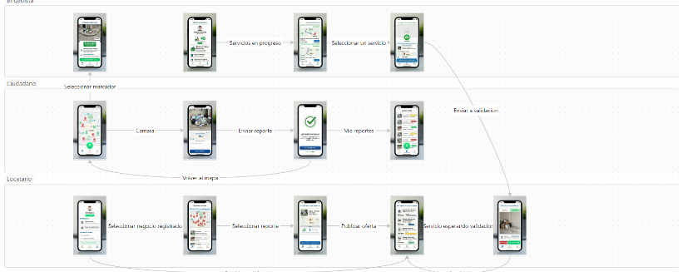
B. High Fidelity Prototype
Using Figma, an interactive prototype adapted to real mobile devices was structured. The "Spot" style guide was respected, characterized by clean contrasts (blues, sanitation greens, and whites), prominent buttons with immediate tactile visual feedback, and optimized typographic sizes according to the RNF-02 requirement. The interactive map visually draws geolocated heat circles that represent the critical foci reported in Mérida.
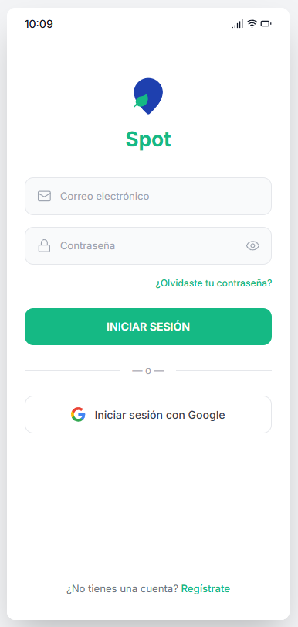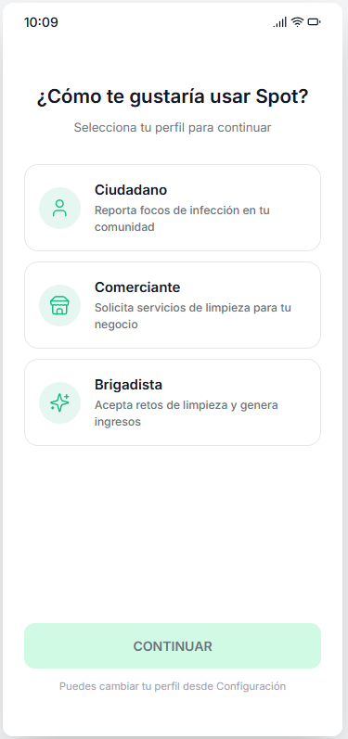
VI. Usability Test Design
To empirically validate the theoretical hypothesis formulated in the KLM predictive model, a rigorous field usability testing plan was formally designed with real users in Mérida.
A. Usability and Performance Goals
The quantitative usability goal states that the user must be able to complete the flow of a new report in a maximum time of 90 seconds, tolerating a maximum of 2 navigation errors as a strict limit and requiring zero assistance from the moderator.
B. Profile and Selection of Participants
Based on Jakob Nielsen's psychometric studies, a sample size of 5 participants of the Citizen profile (young people and adults between 18 and 45 years old) was determined. This number of users ensures the detection of more than 85% of critical interaction failures in the interface. The tests will be carried out under the BYOD (Bring Your Own Device) modality on medium/low-end own devices to guarantee a realistic simulation of the physical performance of the application.
C. Experimental Scenario and Metrics
The experiment will take place outdoors on Calle 65 by 56 in the Historic Center of Mérida (area of high attendance of food establishments). The user will be presented with the following narrative: "You are walking in a hurry back to your office at 12:00 PM, when you find an accumulation of garbage and wet waste that obstructs the pedestrian crossing. Use Spot to report the problem."
During the session, the evaluation team will collect the data using the following standardized performance scale (Table II, Annex at the end of the article).
To ensure the objectivity of the test, there will be separate roles of moderation and collection of grades, and standardized pre- and post-task psychometric questionnaires (SUS system usability scale) will be applied along with the analysis of qualitative comments expressed aloud by the evaluated.
VII. Conclusions and Future Work
The comprehensive development of the "Spot" mobile platform demonstrates that it is feasible to address the complex social problem of leachate and commercial waste in Mérida through accessible mobile technologies of the collaborative economy, overcoming the bureaucratic rigidities of conventional public services.
KLM interaction analysis informed the viability of the user flow by predicting an optimal execution time of 30.05 seconds for the merchants' core task, ensuring that the software can interact organically with the region's fast-paced business environments.
The immediate future work contemplates starting the stage of recruitment of participants and the deployment of experimental field tests in the downtown area of the city of Mérida. The resulting empirical analysis will be used to feed back the prototype, refine the leachate detection algorithms in images and analyze the legal schemes to regulate the safe transport and final disposal of the leachate collected by the brigades, consolidating "Spot" as a pioneering tool for water justice and sustainable urban development in southeastern Mexico.
References
- [1] O. Ceballos Zavala, J. G. Canul Poot, and C. A. Ricárdez Santos, "Development of the web application 'Súbelos al techo!' to improve the urban bus service in the city of Mérida, Yucatán", Human-Computer Interaction, FMAT-UADY, November 2011.
- [2] ReÁnima Soluciones Digitales, "Geofencing: what is it and what are the advantages of implementing it in an app", Recursos Técnicos de Geolocalización, n.d.
- [3] M. Sailer, J. U. Hense, S. K. Mayr, and H. Mandl, "How gamification motivates: An experimental study of the effects of specific game design elements on psychological need satisfaction," Computers in Human Behavior, vol. 69, pp. 371-380, 2017.
- [4] Mérida City Council, "Mérida Móvil: Citizen Attention and Public Services Reports", Official Portal of the Mérida City Council, 2024.
- [5] mySociety, "FixMyStreet: Open source platform for reporting street problems", Urban Crowdsourcing Platform, 2024.
- [6] Environmental Assessment and Enforcement Agency, "Reporta Residuos: Mobile application for citizen vigilance of garbage accumulation", Government of Peru, 2024.
- [7] Government of Guadalajara, "Digital Platform for Urban Reports: I Participate", Municipal Government Portal, 2024.
- [8] Spot Development Team, Project Definition Guide, Requirements Specification (ERS v1.0), Design Analysis Document and Usability Test Plan, Faculty of Mathematics, UADY, May 2026.

Appendices
Table I: Comparative Analysis of Similar Systems
Feature/System | Mérida Mobile (Mérida City Council) | FixMyStreet (mySociety, UK) | Reports Waste (OEFA, Peru) | Yo Participo (Guadalajara, Mex.) | Spot (Proposal)
Reporting Approach | Potholes, lights, garbage. | Damage to urban infrastructure. | Massive accumulation of waste. | Complaints and general services. | Infectious foci and leachate.
Solution Path | Bureaucratic (Governmental). | Government channeling. | State inspection and fines. | Internal municipal management. | Private collaborative economy.
Response Time | Days or weeks. | Variable (subject to budget). | Inspection weeks/months. | Business days of processing. | Immediate (minutes/hours).
Incentive Model | None (civic duty). | None. | Coercive sanctions to districts. | None. | Micro-payments and Gamification.
Trust Mechanism | Traditional municipal folio. | Public transparency map. | Formal registration with digital signature. | Digital service folio. | Geofencing and mutual confirmation.

Table II: User Evaluation and Performance Criteria
Engagement Metrics | Excellent Level | Acceptable Level | Deficient Level
Completion Time | Less than 60 seconds. | Between 60 and 90 seconds. | Greater than 90 seconds (Retirement).
Navigation Errors | 0 wrong clicks. | Between 1 and 2 wrong clicks. | More than 2 clicks out of the flow.
GPS Module Errors | Instant capture. | 1 attempt at manual readjustment. | Georeferencing failure or abandonment.
Request Assistance | Zero questions to the moderator. | 1 Simple clarifying doubt. | Requires help to complete the task.
Global Success Rate | 100% completed | Completed by 80% | Less than 80% of those evaluated.

